DECODELABS: DATA ANALYTICS INTERNSHIP
Project 3: SQL Data Analysis Report

Intern Name: Chisom Promise Onyekaba

Date Submitted: 30th May 2026

Database: DecodeLabs

Dataset: Cleaned Dataset for Data Analytics (DecodeLabs)

Table: orders

Total Rows: 1,200

Tool Used: PostgreSQL 18 / pgAdmin 4

━━━━━━━━━━━━━━━━━━━━━━━━━━━━━━━━
QUERY 1: Sample Data
Business Question: What does our raw dataset look like?
The dataset contains 1,200 order records across 14 columns spanning January 2023 to June 2025.

SQL Code:
SELECT *
FROM orders
LIMIT 10;

Result:
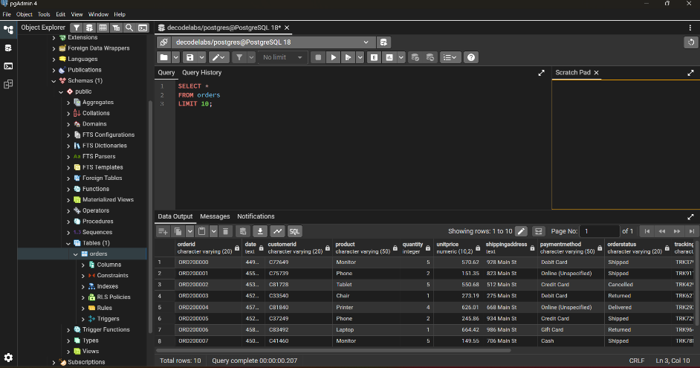
Business Insight:
The dataset contains 1,200 order records across 14 columns including OrderID, Product, TotalPrice and OrderStatus.
━━━━━━━━━━━━━━━━━━━━━━━━━━━━━━━━

QUERY 2: Business KPIs
Business Question: What is our Total Revenue and Average Order Value?
Total revenue is $1,264,761.96 across 1,200 orders with an average order value of $1,053.97.

SQL Code:
SELECT
COUNT (*) AS total_orders,
SUM (TotalPrice) AS total_revenue,
AVG (TotalPrice) AS avg_order_value
FROM orders;

Result:
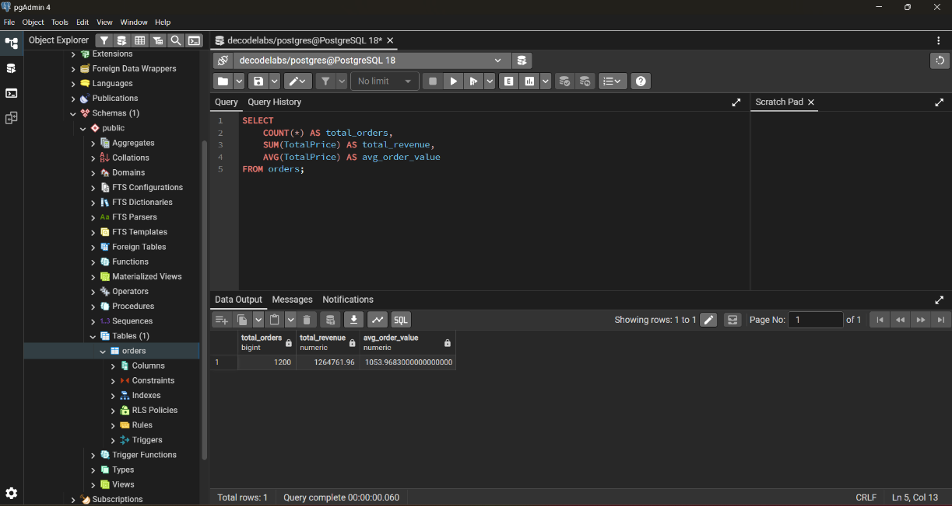
Business Insight:
The dataset contains 1,200 order records across 14 columns including OrderID, Product, TotalPrice and OrderStatus.
━━━━━━━━━━━━━━━━━━━━━━━━━━━━━━━━

QUERY 3: Revenue by Product
Business Question: What is our Top Revenue Product, Lowest Revenue Product and Highest Average Order Value Product?
Chair is the top revenue product at $195,620 while Phone is the lowest at $151,722. Laptop has the highest average order value at $1,111.

SQL Code:
SELECT
Product,
COUNT (*) AS order_count,
SUM (TotalPrice) AS total_revenue,
AVG (TotalPrice) AS avg_revenue
FROM orders
GROUP BY Product
ORDER BY total_revenue DESC;

Result:
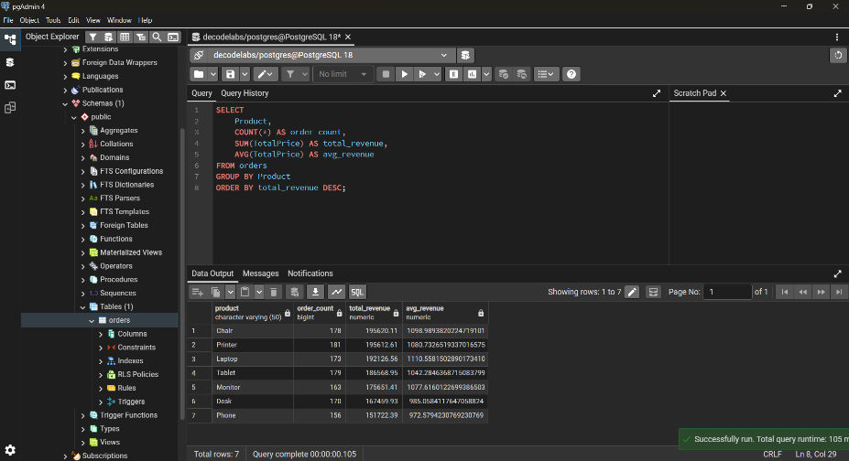
Business Insight:
The dataset contains 1,200 order records across 14 columns including OrderID, Product, TotalPrice and OrderStatus.
━━━━━━━━━━━━━━━━━━━━━━━━━━━━━━━━

QUERY 4: Cancelled Orders
Business Question: How many cancelled orders represent lost Revenue?
250 orders were cancelled representing significant lost revenue. The highest single cancellation was $3,384.90 for a Chair order.
SQL Code:
SELECT
OrderID,
Customer ID,
Product,
TotalPrice,
Date
FROM orders
WHERE OrderStatus = 'Cancelled'
ORDER BY TotalPrice DESC;

Result:
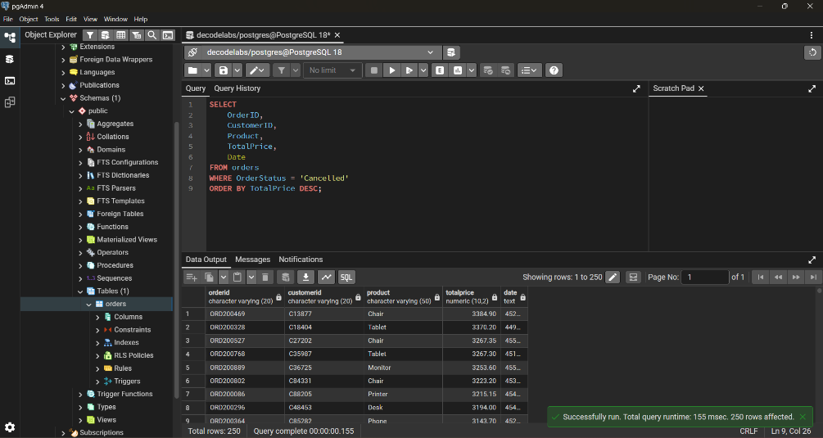
Business Insight:
The dataset contains 1,200 order records across 14 columns including OrderID, Product, TotalPrice and OrderStatus.
━━━━━━━━━━━━━━━━━━━━━━━━━━━━━━━━

QUERY 5: Order Status
Business Question: What is the comprehensive Order Status?
Only 19.3% of orders are successfully Delivered. Combined Cancelled and Returned orders represent 41.4% of all orders; a critical operational problem.

SQL Code:
SELECT
OrderStatus,
COUNT (*) AS order_count,
ROUND (COUNT (*) * 100.0 / 1200, 1) AS percentage
FROM orders
GROUP BY OrderStatus
ORDER BY order_count DESC;

Result:
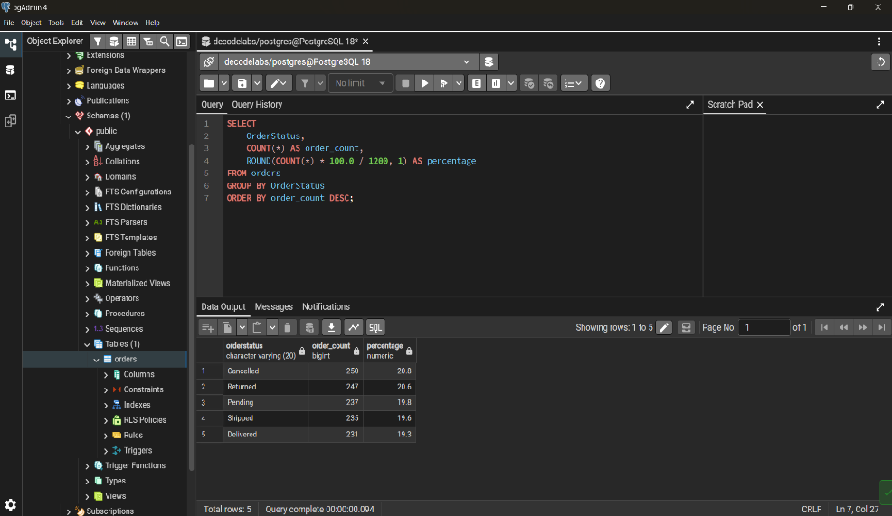
Business Insight:
The dataset contains 1,200 order records across 14 columns including OrderID, Product, TotalPrice and OrderStatus.
━━━━━━━━━━━━━━━━━━━━━━━━━━━━━━━━

QUERY 6: VIP Orders
Business Question: How many VIP Orders in Total?
34 VIP customers placed orders above $3,000. The highest single order was $3,456.40 for a Tablet. These customers should be targeted with a loyalty program.

SQL Code:
SELECT
OrderID,
Customer ID,
Product,
TotalPrice
FROM orders
WHERE TotalPrice > 3000
ORDER BY TotalPrice DESC;

Result:
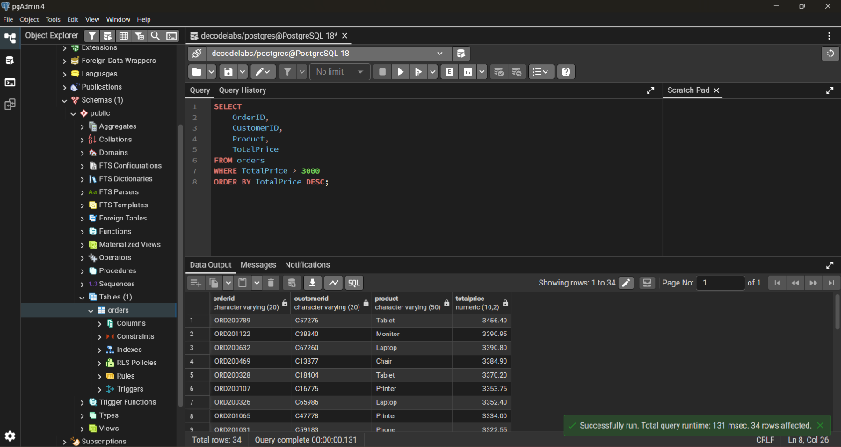
Business Insight:
The dataset contains 1,200 order records across 14 columns including OrderID, Product, TotalPrice and OrderStatus.
━━━━━━━━━━━━━━━━━━━━━━━━━━━━━━━━

QUERY 7: Referral Source
Business Question: How has the referral program performed?
Instagram is the top marketing channel generating $275,285 from 259 orders. The Referral program is the weakest at $226,816 and needs restructuring.

SQL Code:
SELECT
ReferralSource,
COUNT (*) AS orders,
SUM (TotalPrice) AS total_revenue,
AVG (TotalPrice) AS avg_order_value
FROM orders
GROUP BY ReferralSource
ORDER BY total_revenue DESC;

Result:
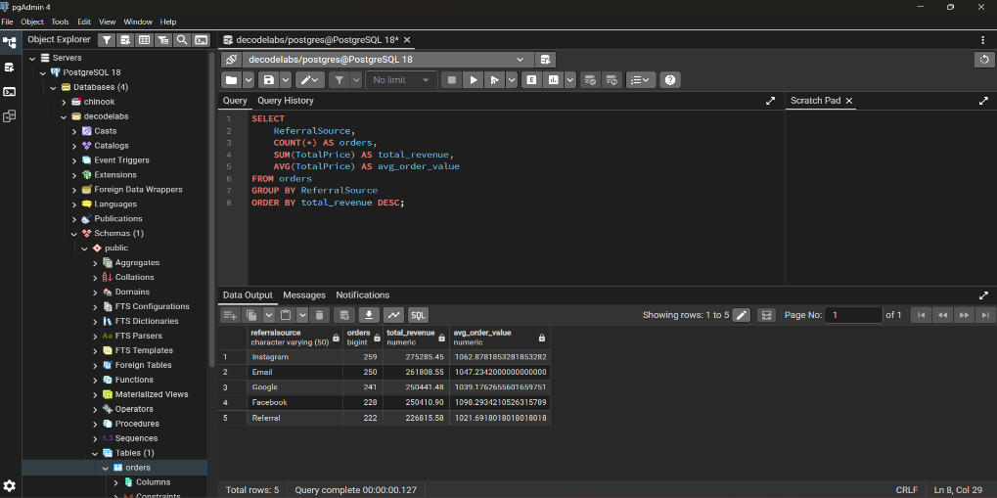
Business Insight:
The dataset contains 1,200 order records across 14 columns including OrderID, Product, TotalPrice and OrderStatus.
━━━━━━━━━━━━━━━━━━━━━━━━━━━━━━━━

QUERY 8: Monthly Trend
Business Question: What is the Highest and Lowest performing month?
June is the peak month at $170,616 with 147 orders. September is the worst at $69,322 with only 73 orders; a 59% revenue gap between best and worst months.

SQL Code:
SELECT
EXTRACT (MONTH FROM Date: :DATE) AS month_number,
COUNT (*) AS orders,
SUM (TotalPrice) AS revenue
FROM orders
GROUP BY month_number
ORDER BY month_number;

Result:
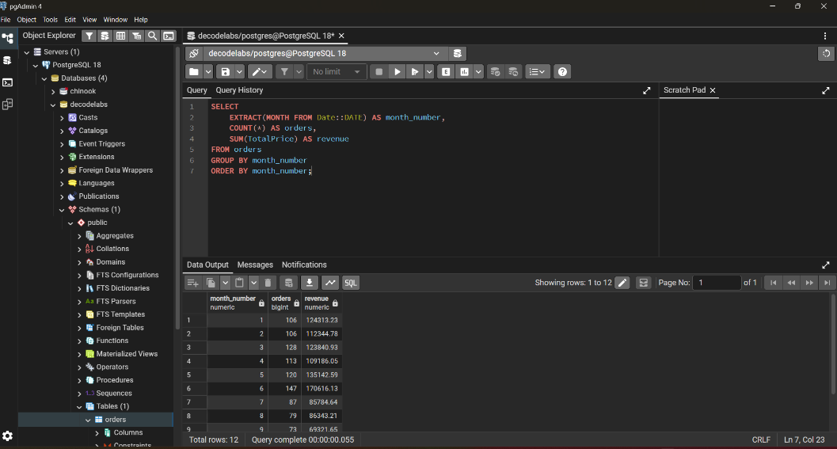
Business Insight:
The dataset contains 1,200 order records across 14 columns including OrderID, Product, TotalPrice and OrderStatus.
━━━━━━━━━━━━━━━━━━━━━━━━━━━━━━━━

QUERY 9: Payment Method
Business Question: What payment method generated the most revenue?
Credit Card generates the most revenue at $263,848. Debit Card has the lowest average order value at $1,002 suggesting smaller purchase behavior.

SQL Code:
SELECT
PaymentMethod,
COUNT (*) AS orders,
SUM (TotalPrice) AS total_revenue,
AVG (TotalPrice) AS avg_order_value
FROM orders
GROUP BY PaymentMethod
ORDER BY total_revenue DESC;

Result:
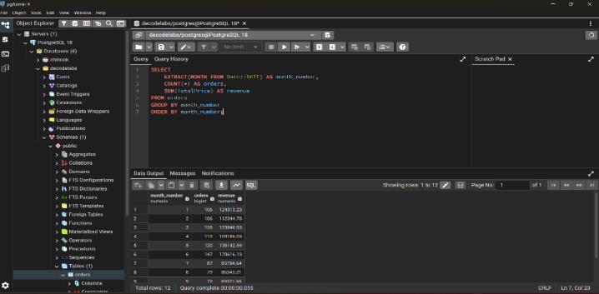
Business Insight:
The dataset contains 1,200 order records across 14 columns including OrderID, Product, TotalPrice and OrderStatus.
━━━━━━━━━━━━━━━━━━━━━━━━━━━━━━━━

QUERY 10: Coupon Analysis
Business Question: Which Coupon was most used?
FREESHIP is the most used coupon with 313 uses generating $335,037. Customers with No Coupon still generate $322,401 showing strong organic demand.

SQL Code:
SELECT
CouponCode,
COUNT (*) AS orders,
SUM(TotalPrice) AS total_revenue,
AVG (TotalPrice) avg_order_value
FROM orders
GROUP BY CouponCode
HAVING COUNT (*) > 290
ORDER BY total revenue DESC;

Result:
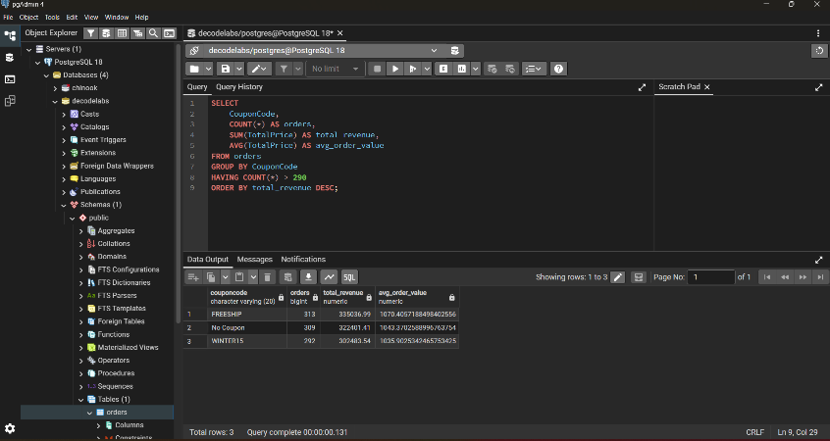
Business Insight:
The dataset contains 1,200 order records across 14 columns including OrderID, Product, TotalPrice and OrderStatus.
━━━━━━━━━━━━━━━━━━━━━━━━━━━━━━━━

